# Setup web application on Apache web server

Setup on linux server.

1. Update the linux server

>> sudo apt update

1. install apache software

>> sudo apt install apache2

1. check apache status

>> systemctl status apache2

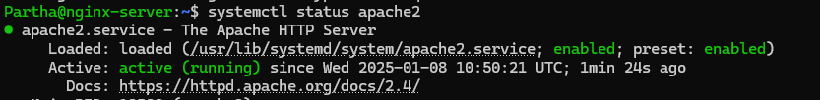

1. Check out the port for apahe

>> sudo ss -nptl



1. Browse and check the apache default running

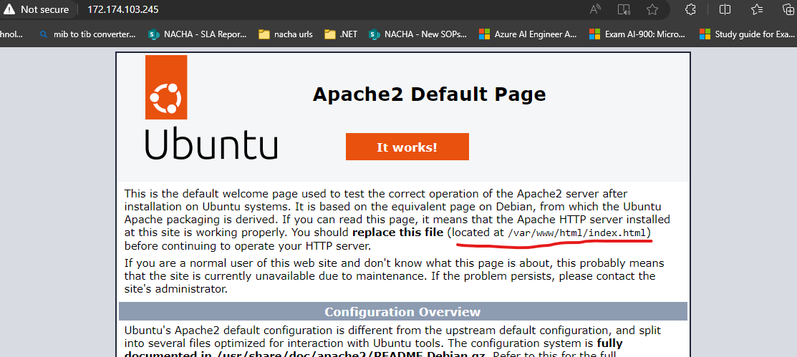

Note- the apache also take the default application path as same as nginx “/var/www/html”

So the advantage is if we were running an application the the server by nginx or any other and we removed that software and install apache directly it will pick the application running and start serving on port 80.

It will not place default page in this case, so no manual interruption required.

1. If new server setup the application. Make sure to remove default page first else may see error as below.



1. Configurations including port

* apache2.conf is the main configuration file. It puts the pieces together by including all remaining configuration files when starting up the web server.
* ports.conf is always included from the main configuration file. It is used to determine the listening ports for incoming connections, and this file can be customized anytime.
* Configuration files in the mods-enabled/, conf-enabled/ and sites-enabled/ directories contain particular configuration snippets which manage modules, global configuration fragments, or virtual host configurations, respectively.

*/etc/apache2/*

*|-- apache2.conf*

*| `-- ports.conf*

*|-- mods-enabled*

*| |-- *.load*

*| `-- *.conf*

*|-- conf-enabled*

*| `-- *.conf*

*|-- sites-enabled*

*| `-- *.conf*

Change the application port to 81

Go to “/etc/apache2” edit “ports.conf” to change port.

Change NSG rule to allow traffic from new port 81.

After change restart apache2 to reflect change if not automatically.

>> sudo systemctl restart apache2 (# Ubuntu/Debian)

>> sudo systemctl restart httpd (# CentOS/RHEL)

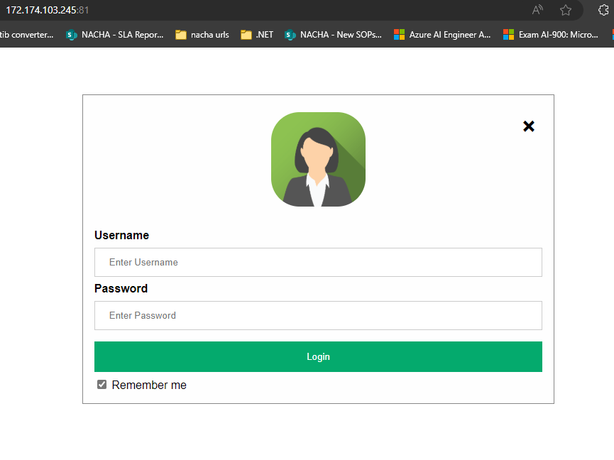

Note- enable the apache service and also start if not done automatically.

>> sudo systemctl enable httpd

(this enabled will help to run apache when the server is booted).

>> sudo systemctl start httpd

Setup on windows server.

1. What is different between apache and apache tomcat

* The main difference between Apache and Apache Tomcat is that Apache is a general-purpose web server that serves static content, while Tomcat is a Java application server that serves dynamic content.
* Purpose: Apache is a web server that serves static content like HTML, images, audio, and text. Tomcat is a Java application server that serves dynamic content like Java Servlets and JSP files.

1. Install apache on the windows server.

Go to apache official site -> go for download

url - [Download - The Apache HTTP Server Project](https://httpd.apache.org/download.cgi)

Go for third party vendors.

Go for apache Lounge

Download zip for windows

Unzip (extract) to “c” drive.

If it asks for any kid of permission allow.

One the extract is done we will be able to see apache files.

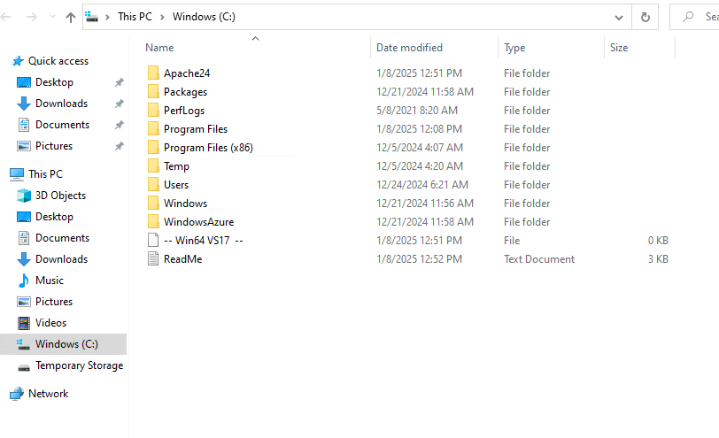

1. Now we need to install apache on server

The installation file will be inside apache24 -> bin

And the installation file is httpd

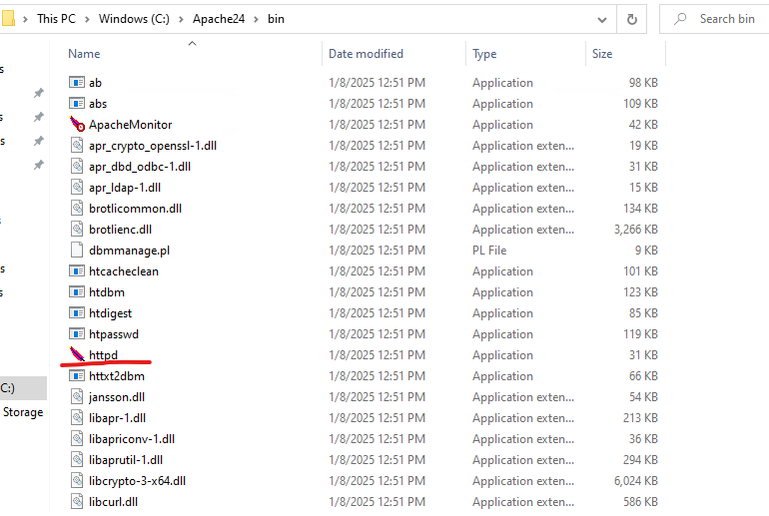

Open cmd ad go to location “C:\Apache24\bin”

Run command >> httpd -k install

This will install apache on the server.

Encountered error during the time of installation.

Reason-

The error message you're seeing indicates that the required Visual C++ Redistributable (specifically the VCRUNTIME140.dll file) is missing from your system. This DLL is part of the Microsoft Visual C++ Redistributable package, which provides runtime components necessary for running applications developed with Visual Studio.

Here’s how you can fix this issue:

**Download and Install the Visual C++ Redistributable-**

**Visit the official Microsoft download page** for the Visual C++ Redistributable for Visual Studio 2015, 2017, and 2019:

* + [Microsoft Visual C++ Redistributable](https://support.microsoft.com/en-us/help/2977003/the-latest-supported-visual-c-downloads)

Download the **x64** and **x86** versions of the redistributable depending on your system (if you're unsure, it's best to install both).

* + **x64**: For 64-bit systems
  + **x86**: For 32-bit systems

Once downloaded, run the installer for both versions to install the required libraries.

After installation, **restart your computer** to ensure the changes take effect.

**Retry Apache Installation**

Issue was not resolved so installed “visual studio” with all c++ dependency. And created project with c++ so all c++ dependencies installed.

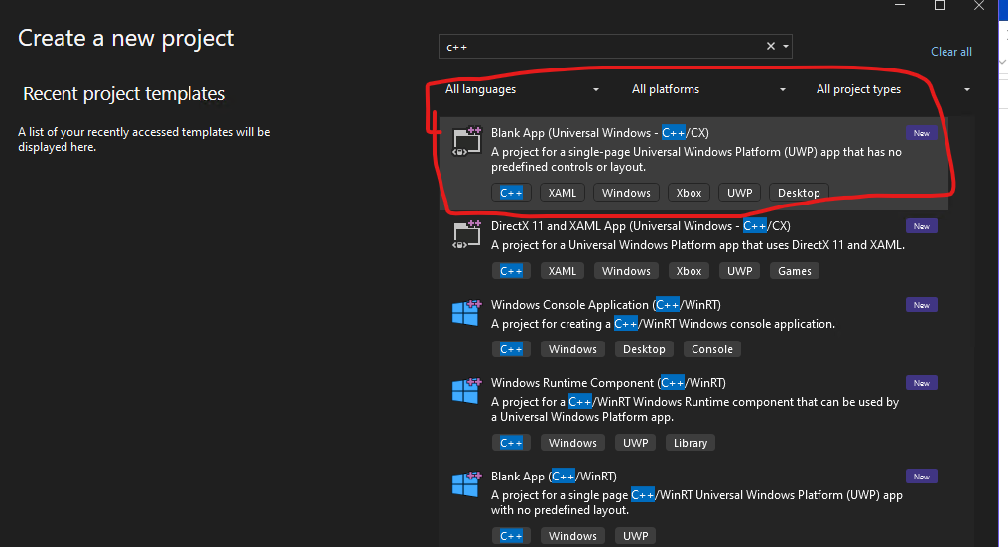

Rebooted the server.

Retried to install apache.

Note- to install CMD should be on admin mode.

>> httpd -k install

1. Try to browse locally and confirm.

Not running check the services and make sure apache service is running successfully.

Start the service.

Failed to start the service. Got an error “windows could not start apache 2.4 on local computer for more info review system log"

This is due to apache configuration has some error.

When Apache fails to start on a Windows machine and shows the error message **"Windows could not start Apache 2.4 on Local Computer"**, it typically indicates that there is an issue with the Apache configuration or with the environment on which it's running. Here are the steps to troubleshoot and fix the issue:

**1. Check the System Logs**

* Open the **Event Viewer** in Windows to look for more detailed information about the error.
  + Press Windows + R, type eventvwr.msc, and hit **Enter**.
  + In the left pane, navigate to **Windows Logs** → **Application**.
  + Look for **Error** events related to Apache or httpd.exe. This can provide additional clues.

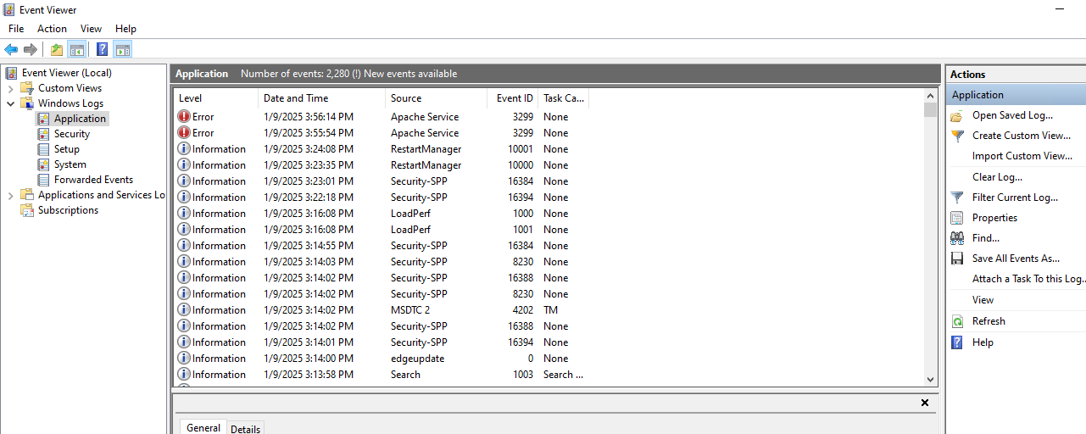

Checked for the error.

This error clearly indicates that there is some issue with the path on configuration file.

The error message you are seeing indicates that there is a **syntax error** in your Apache configuration file (httpd.conf) related to the ServerRoot directive. Specifically, it tells you that **ServerRoot must be a valid directory**.

**Explanation:**

The ServerRoot directive specifies the directory where Apache's configuration, error logs, and other server-related files are located. In this case, line 39 of your httpd.conf has an invalid directory path for ServerRoot.

**Solution:**

1. **Open the httpd.conf file**:
   * Open the file located at:

bash

Copy code

C:/Users/ParthasarathiPanda/Downloads/httpd-2.4.62-240904-win32-vs17/Apache24/conf/httpd.conf

* + Use a text editor like Notepad, Notepad++, or any code editor to open the file.

1. **Locate the ServerRoot directive**:
   * Look for the line starting with:

arduino

Copy code

ServerRoot "C:/Users/ParthasarathiPanda/Downloads/httpd-2.4.62-240904-win32-vs17/Apache24"

1. **Correct the ServerRoot directory**:
   * Ensure that the directory specified in ServerRoot is **valid** and **correct**. It should point to the root directory of your Apache installation.

For example, if your Apache is installed in the folder C:/Apache24, the correct line should look like this:

apache

Copy code

ServerRoot "C:/Apache24"

Checked in file and the default path was set to “c:/apache24” but later we changes the path to download folder currently the apache was on download.

So modified the path.

Restarted the apache configuration.

>> httpd.exe -k restart



Service started running successfully.

Application comes up on browser.

NOTE- if we directly extract the apache to c drive then we will not face this issue. If any other drive or location then we need to change.

1. Remove default html and clone our project to run.

Go to apache and go for “htdocs”.

Delete default index page. Clone repo or project here.

1. Check application availability.

1. Make sure the apache service is defined to automatic to start automatically after reboot the server.

1. Browse externally by server ip to confirm external availability of the application.

Azure vm having issue to get application browser after adding port.

Tried to change port and run locally it worked.

To change the port go to apache folder and go for conf and then to httpd.

Edit listening port.

Restart apache.

Note- this will be performed from bin only.

>> httpd.exe -k restart

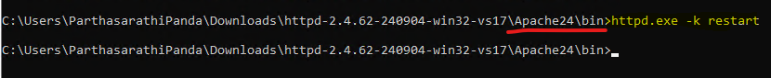

Browse by new port.

